Gold Coast Back Printer Driver Download
Ricoh Printer IM C6000
(MacOS)
YouTube Link: https://youtu.be/oSVEcyxDzyw

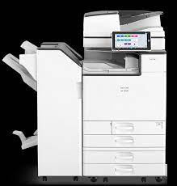

Instructions

Step 1

- Go to eakes.com

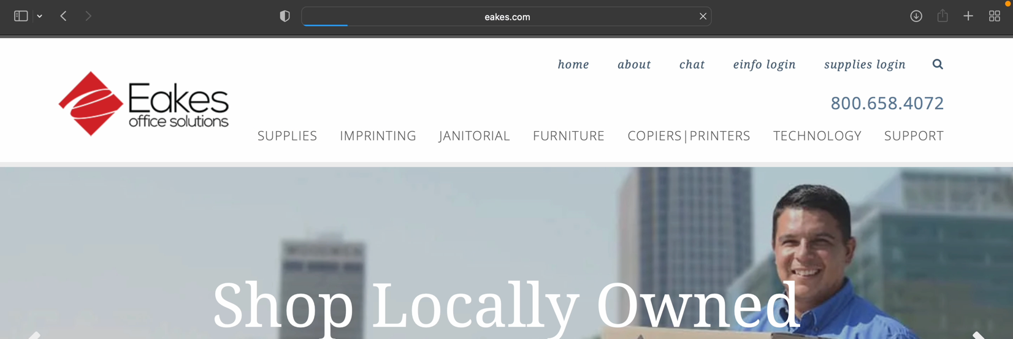

Step 2

- Hover over the “Support” sub menu, and then click on “Driver Downloads”

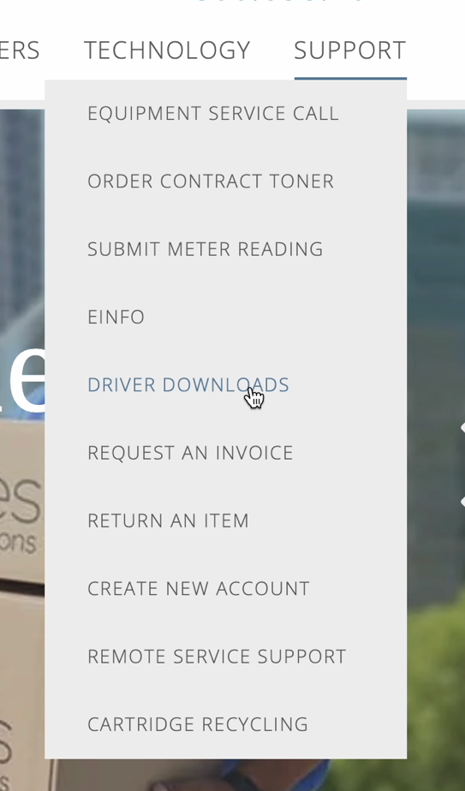

Step 3

- Scroll down and click on the photo of the “RICOH – Ricoh Drivers”

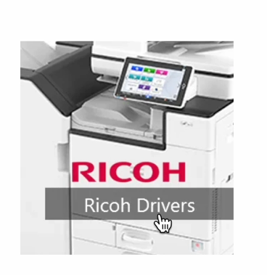

Step 4

- In the Search for downloads box, search “IM C6000” and click the magnified glass

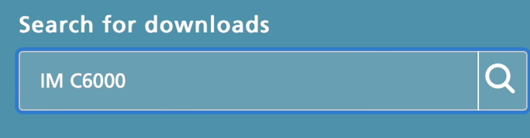

Step 5

- Scroll down to Model: IM C6000 Plus, and click on “IM C6000 Plus”

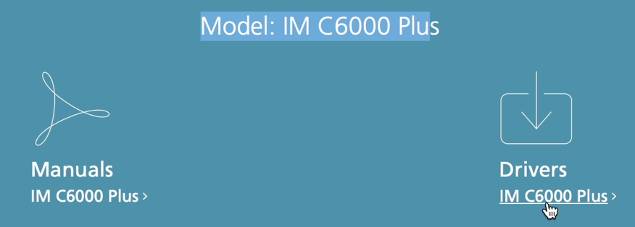

Step 6

- Click “I Agree” to the Software License Agreement

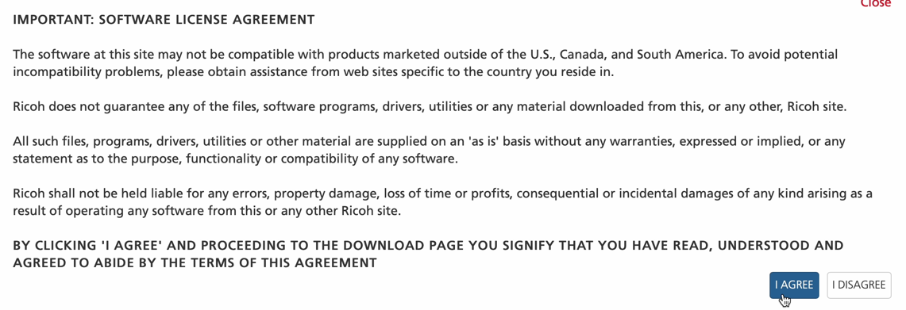

Step 7

- Be sure to choose “Mac OS X” then in the top left-hand corner of your Mac select the apple icon and click “About this Mac” to see what version of Mac OS you are running on your machine. Select the correct Version then click the blue “Download” button for the PPD Installer
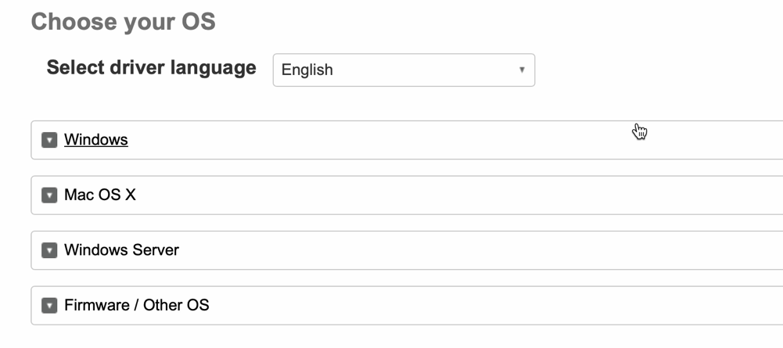

Step 8

- Locate the downloaded zip file by navigating to your Dock then to your Finder Application and then your Downloads Folder. The file should read “Ricoh_IM_C3…IO_1.8.0.0.dmg”. open this file.

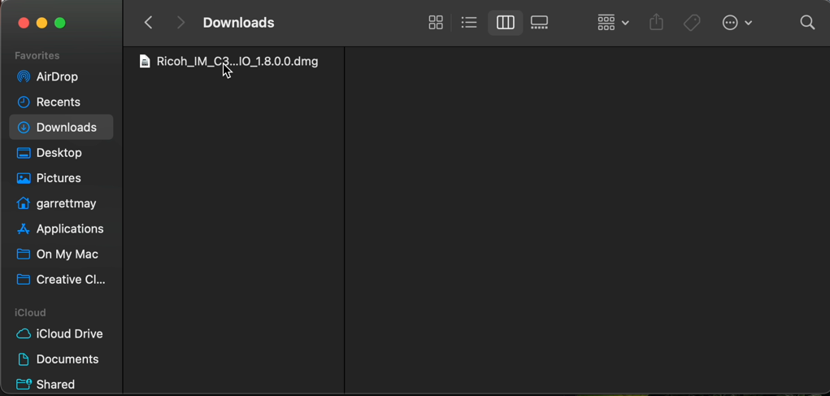

Step 9

- Click to open the driver package installer titled “Ricoh_IM_C3000_C3500_C4500_LIO_Driver.pkg”

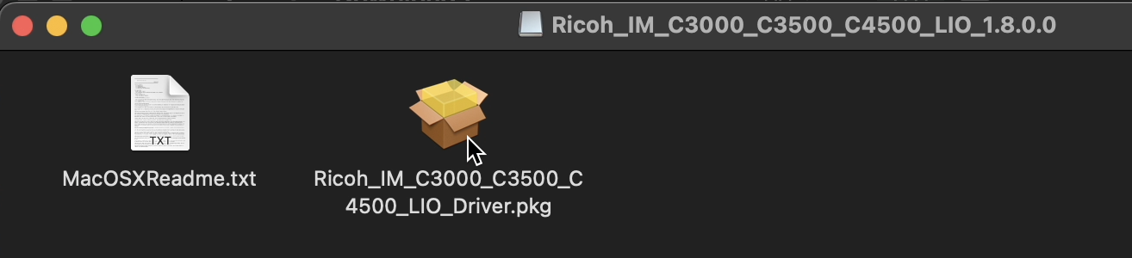

Step 10

- Follow the installer prompts to install the driver by clicking “Continue”.

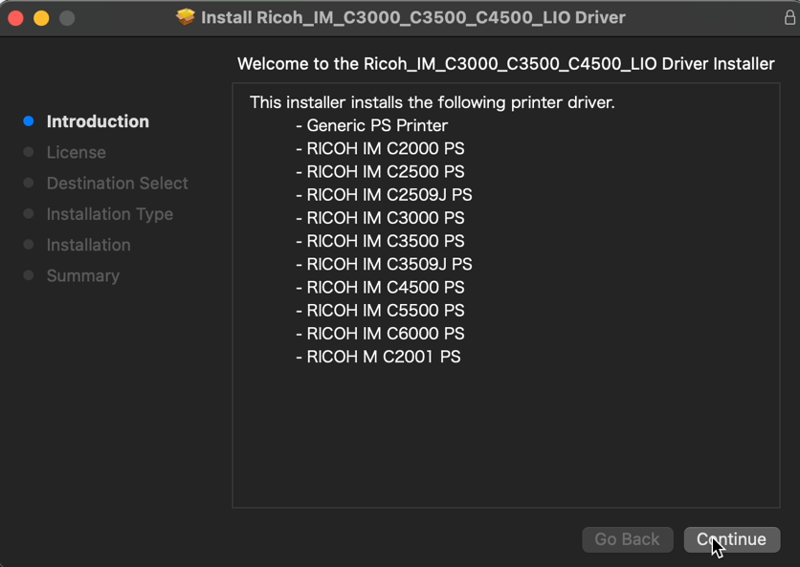

Step 11

- Agree to the terms of the Software License Agreement.

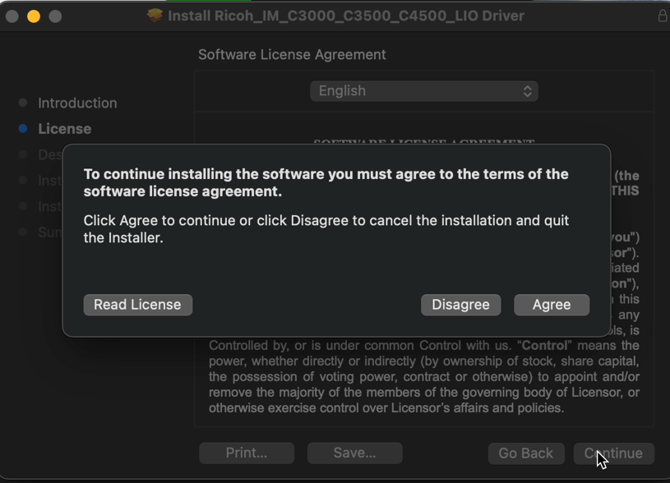

Step 12

- Click “Install” and enter in your computer password (if prompted).

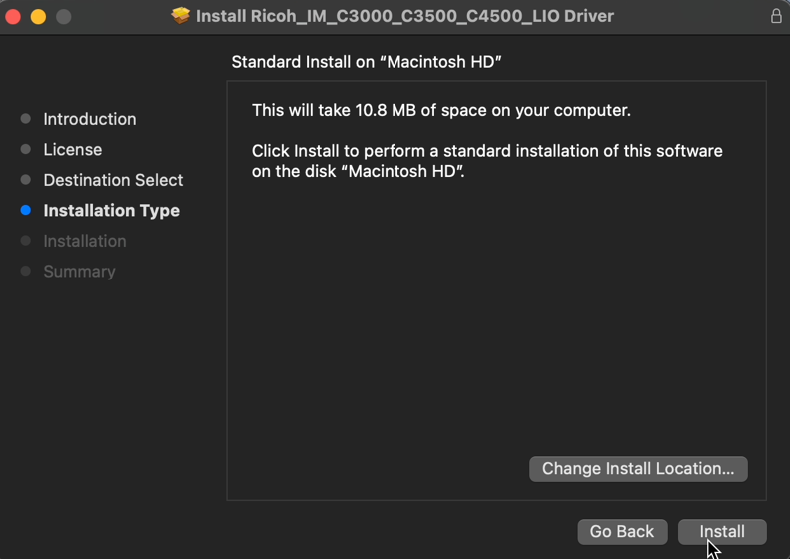

Step 13

- The Installation should be complete, please close the installation package and select to “Move it to trash” as it’s no longer needed.

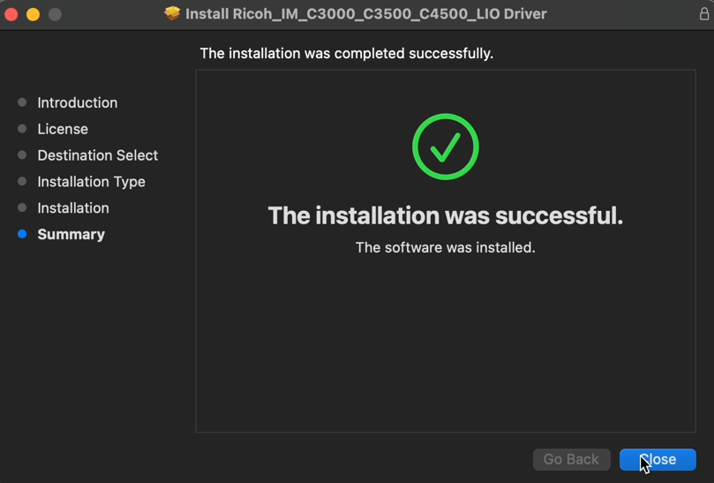

Step 14

- Next, navigate to you System Preferences in your Dock or by clicking the apple icon in the top left-hand corner of your screen. Next select “Printers & Scanners”.

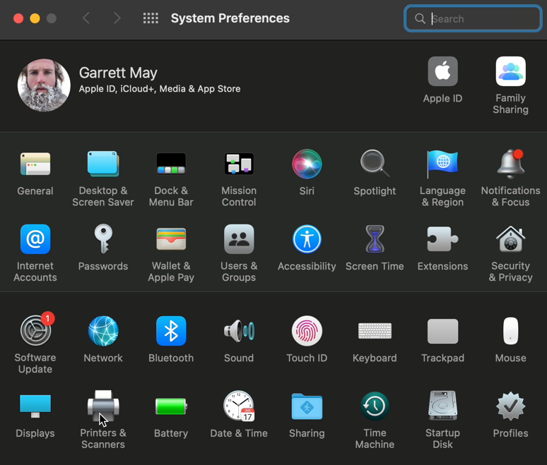

Step 15

- Next, select the “+” sign in the bottom left-hand corner of the printer settings to add the new printer.

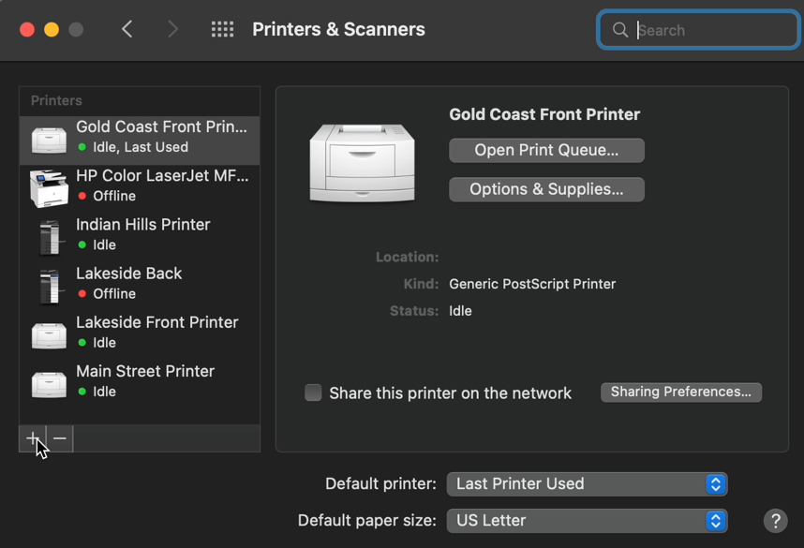

Step 16

- Next click on the Network Globe in the middle tab of the “add printer” settings. Enter in the IP address: Gold Coast Front 192.168.75.220 Gold Coast Back 192.168.75.221, Indian Hills 192.168.10.250, Skyline Printer One 192.168.22.218, Two 192.168.22.219, Three 192.168.22.220, Four 192.168.22.221, Five 192.168.22.222, Main Street 192.168.20.250, Old Market, 192.168.50.250 You can then rename the printer to Gold Coast Back Printer or whatever you like. Then make sure the “Use” field is selected on “RICOH IM C6000 PS”, if not click the drop down and navigate to this driver. Then click “Add”.

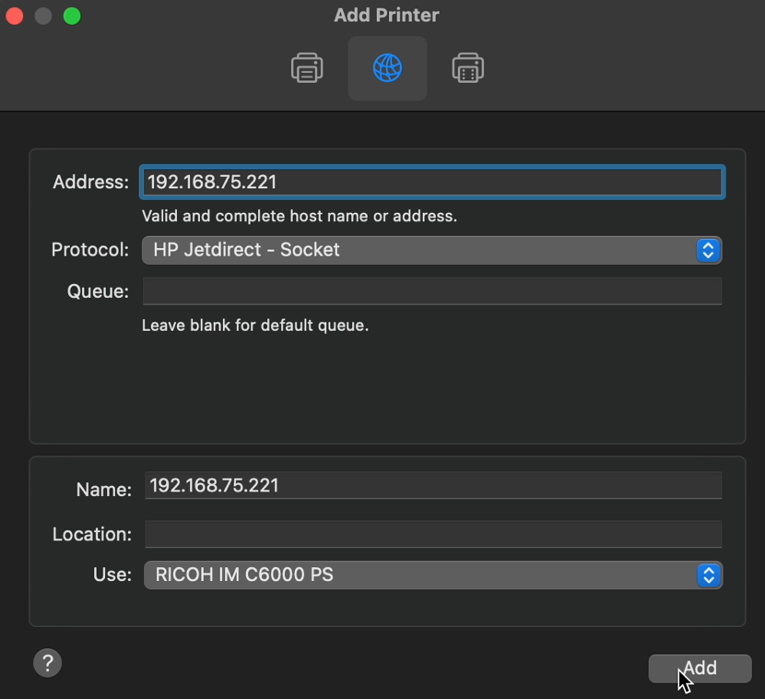

Step 17

- While it’s adding the printer click the “Configure” to add the printer features.

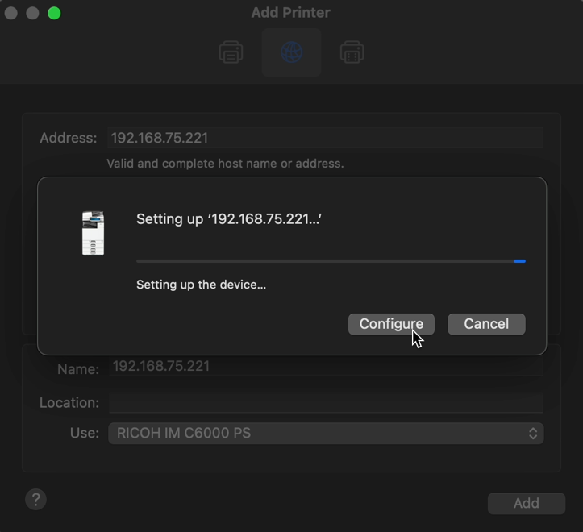

Step 18

- Configure features are as follows:

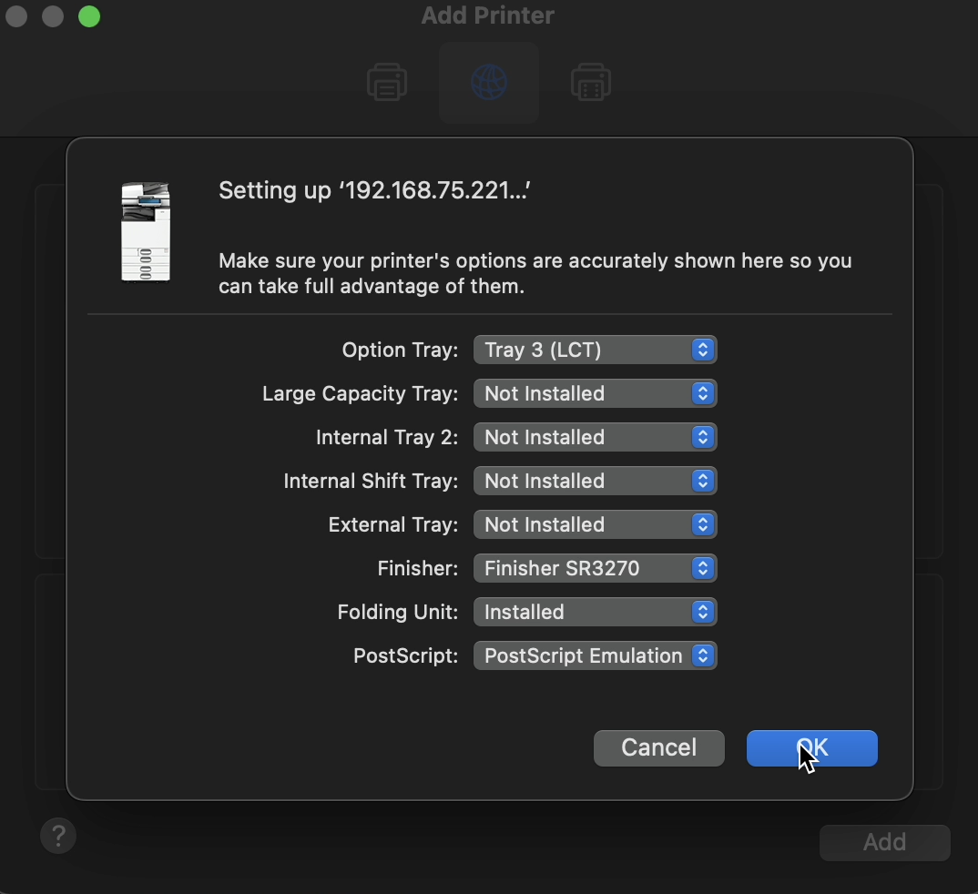

Step 19

- And that’s it, you’re done. Please do a test print to make sure the drivers are working correctly.

