Gold Coast Back Printer Driver Download
Ricoh Printer IM C6000
(Windows 10)
YouTube Link: https://youtu.be/8N49BPiaIL8

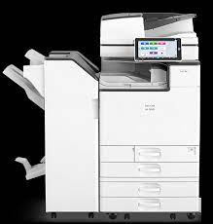

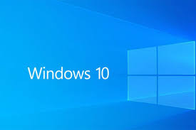

Instructions

Step 1

- Go to eakes.com

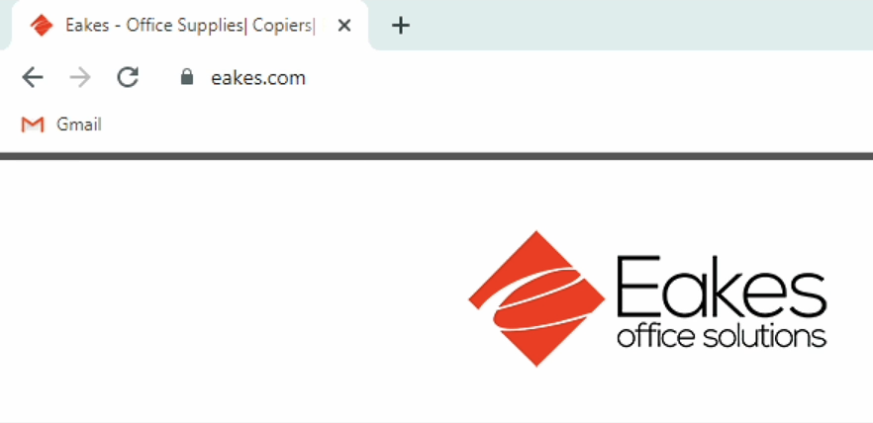

Step 2

- Hover over the “Support” sub menu, and then click on “Driver Downloads”

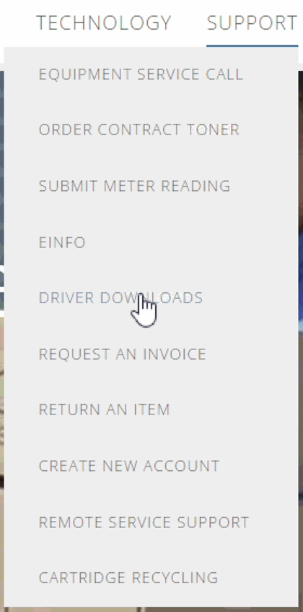

Step 3

- Scroll down and click on the photo of the “RICOH – Ricoh Drivers”

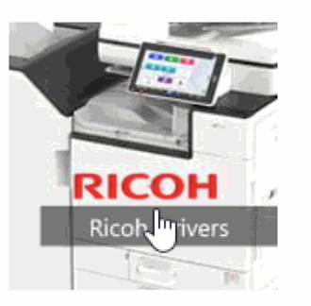

Step 4

- In the Search for downloads box, search “IM C6000” and click the magnified glass

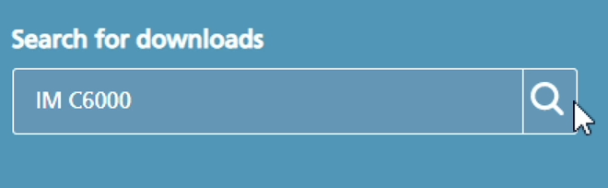

Step 5

- Scroll down to Model: IM C6000 Plus, and click on “IM C6000 Plus”

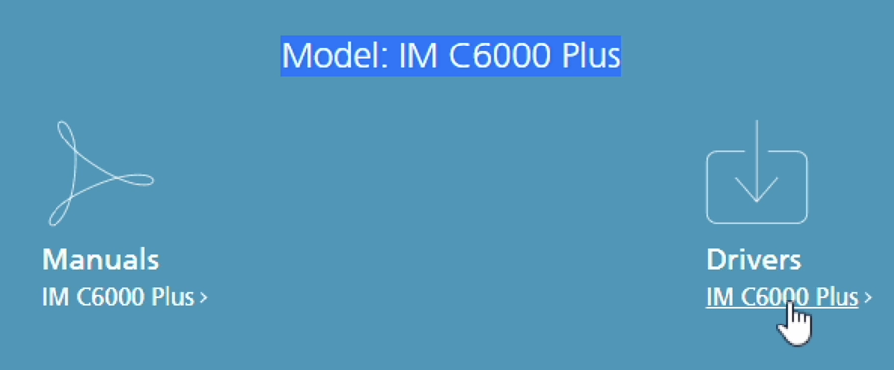

Step 6

- Click “I Agree” to the Software License Agreement

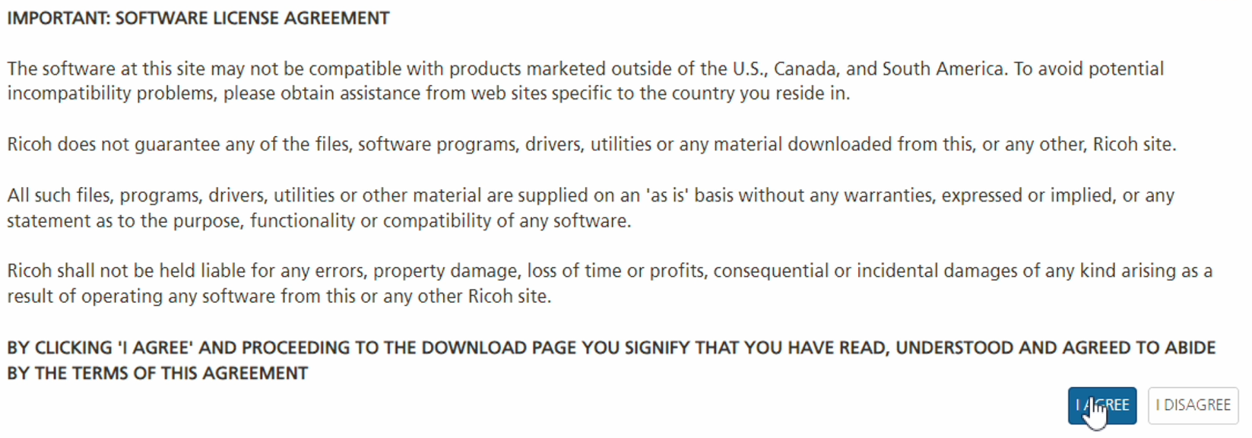

Step 7

- Be sure you have the correct OS selected at the top, if not click “Choose other OS”. If Windows 10 is correct click the blue “Download” button for the PCL 6 Driver.

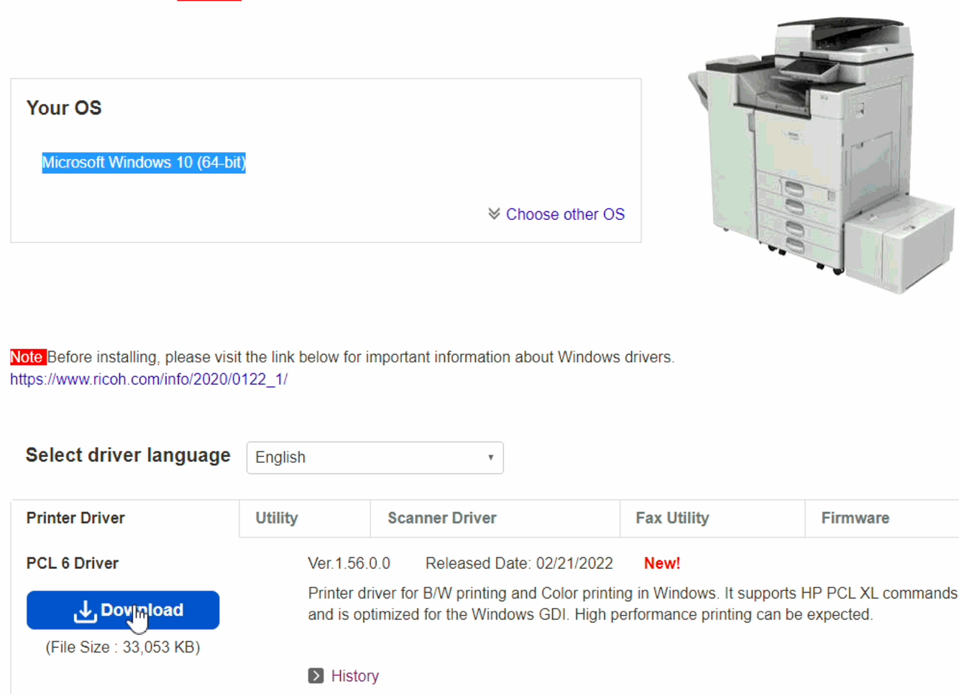

Step 8

- The file will be download to your downloads folder in your file explorer (folder icon). Take note of the file name, it should be “z96353L18”. Click “Save”

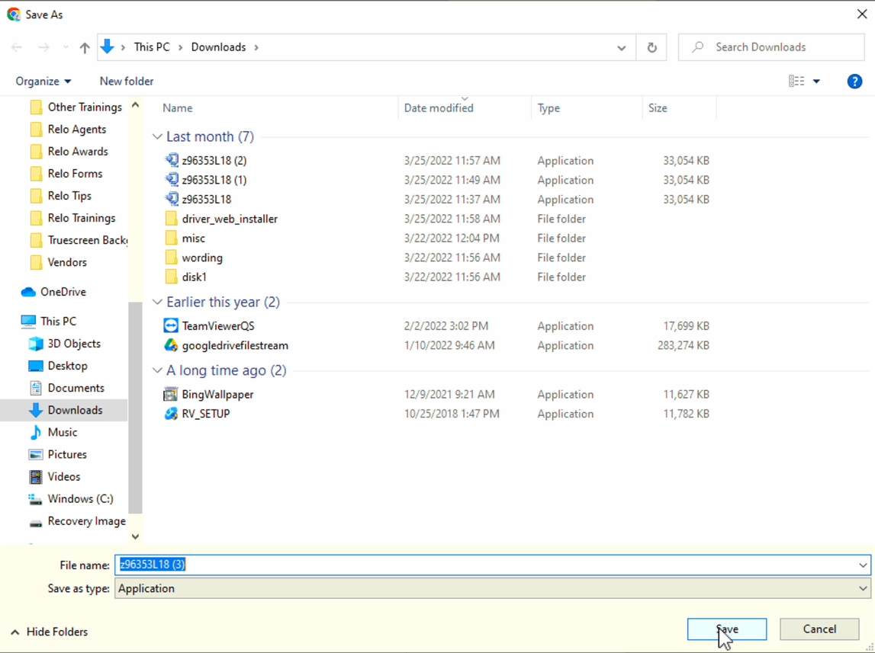

Step 9

- Open your file explorer icon (yellow folder), navigate to your downloads folder and find the file “z96353L18”. Right click on your mouse and select “Open” or “Run as administrator”

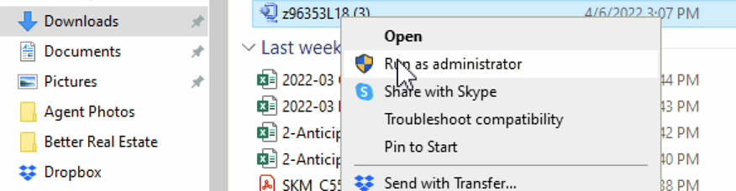

Step 10

- Note the location your system is placing your file. It should default to your Windows C Drive and in your “temp” folder. C:/temp/z96353L18. Then click “Unzip”

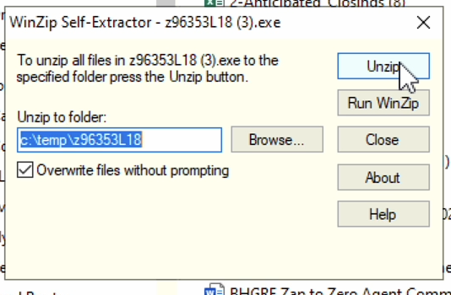

Step 11

- Navigate to your “Windows (C:)” drive in file explorer, then find your “temp” folder and open it.

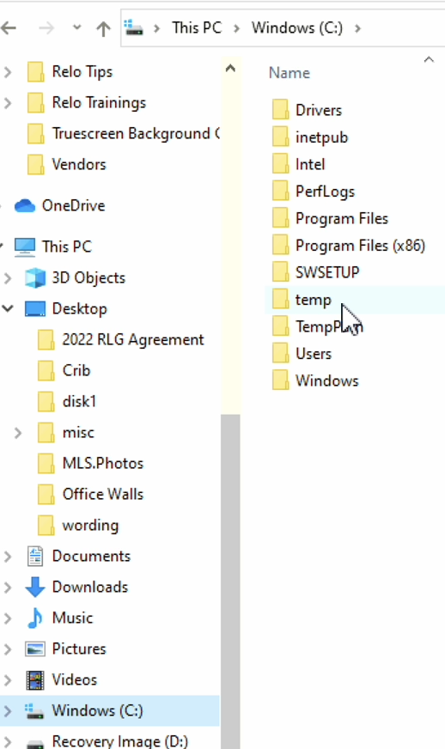

Step 12

- Open the driver file “z96353L18”

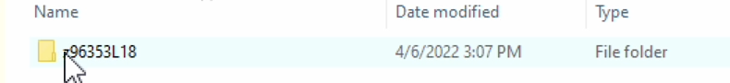

Step 13

- Find the “RV_SETUP” application and open it.

Step 14

- Allow this app to make changes to your device (if asked)

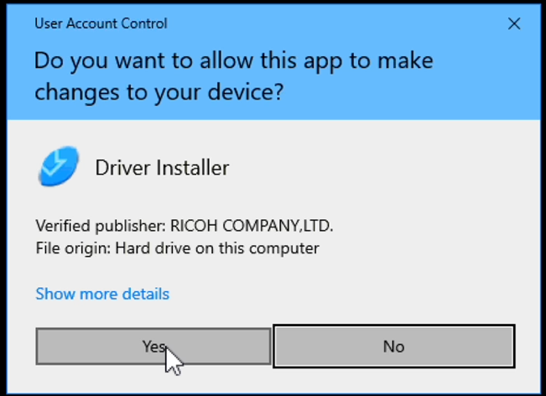

Step 15

- Agree to the End User License Agreement and then click “Next” and follow the Install Steps.

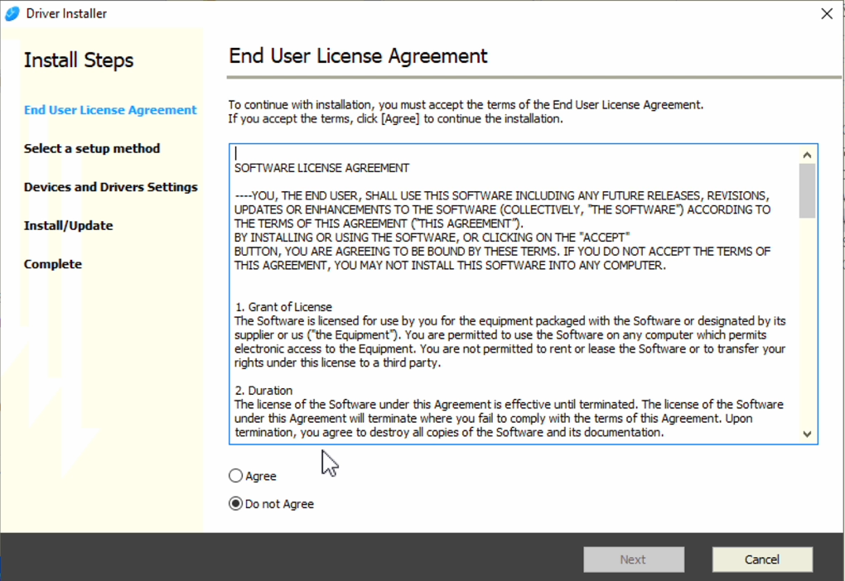

Step 16

- Keep “Network” selected on the setup method then click “Next”

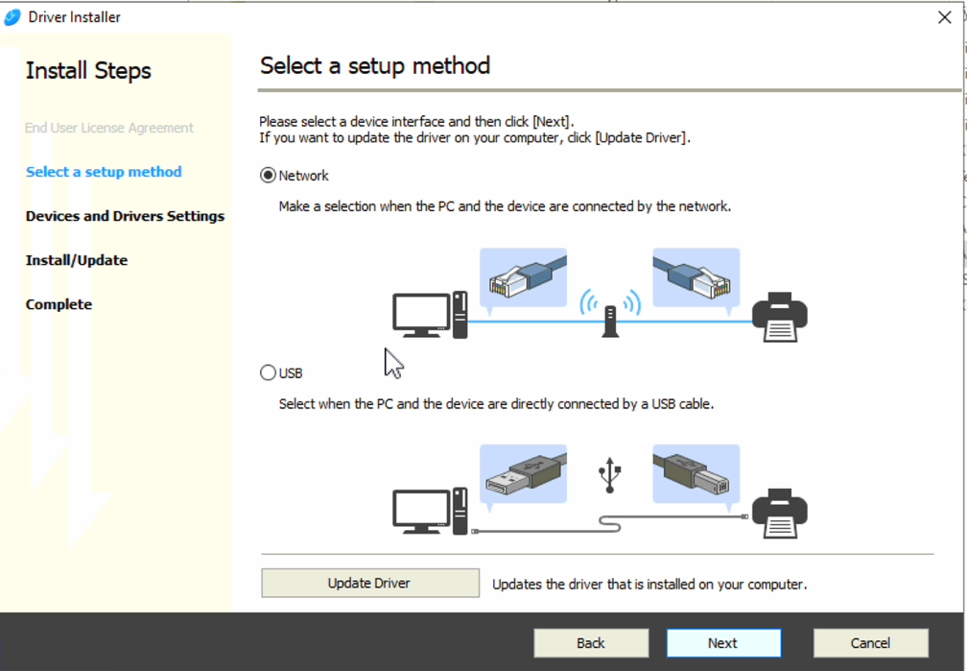

Step 17

- Make sure the correct printer is selected for your office (IM C6000) and IP Address Gold Coast Front 192.168.75.220 Gold Coast Back 192.168.75.221, Indian Hills 192.168.10.250, Skyline Printer One 192.168.22.218, Two 192.168.22.219, Three 192.168.22.220, Four 192.168.22.221, Five 192.168.22.222, Main Street 192.168.20.250, Old Market, 192.168.50.250, click “Next”

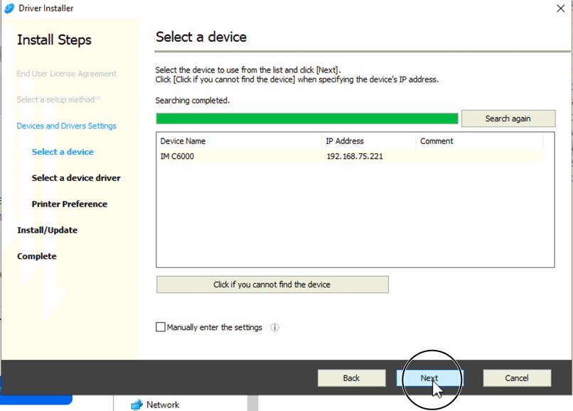

Step 18

- You are all finished with the install. If you’d like you can Install the “Device Software Manager” by checking the box and clicking “Next” but it’s not needed. Go ahead and click “Next” with the box unchecked.

Step 19

- Lastly, click “Print Test Page” make sure a page prints to the printer then click “Finish” and you are all done.

